Assignment 02A

Title: Create version control account on GitHub and use Git commands to create a repository and push your code to GitHub.
Following steps are followed to Create a repository and push your code on GitHub. 1]Go to https://github.com
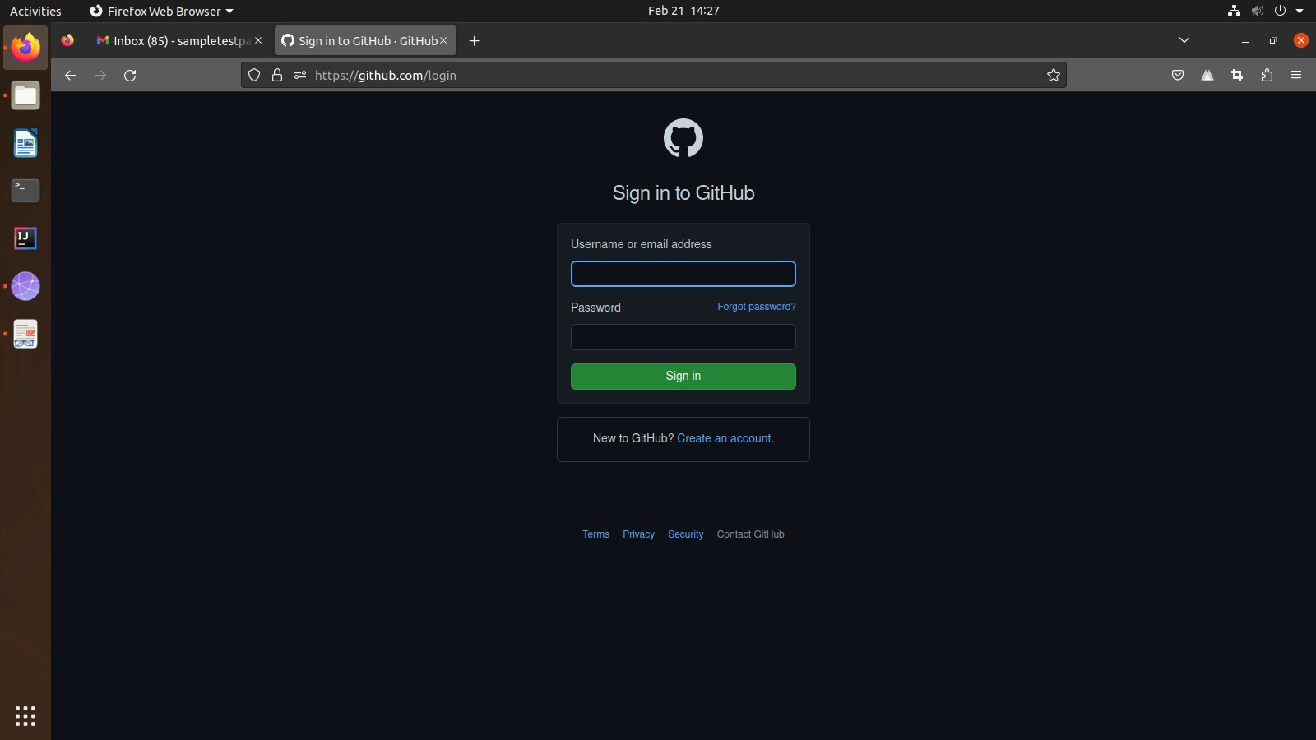
You are required to sign in to your account or if not having an account you have then click on Create an account.
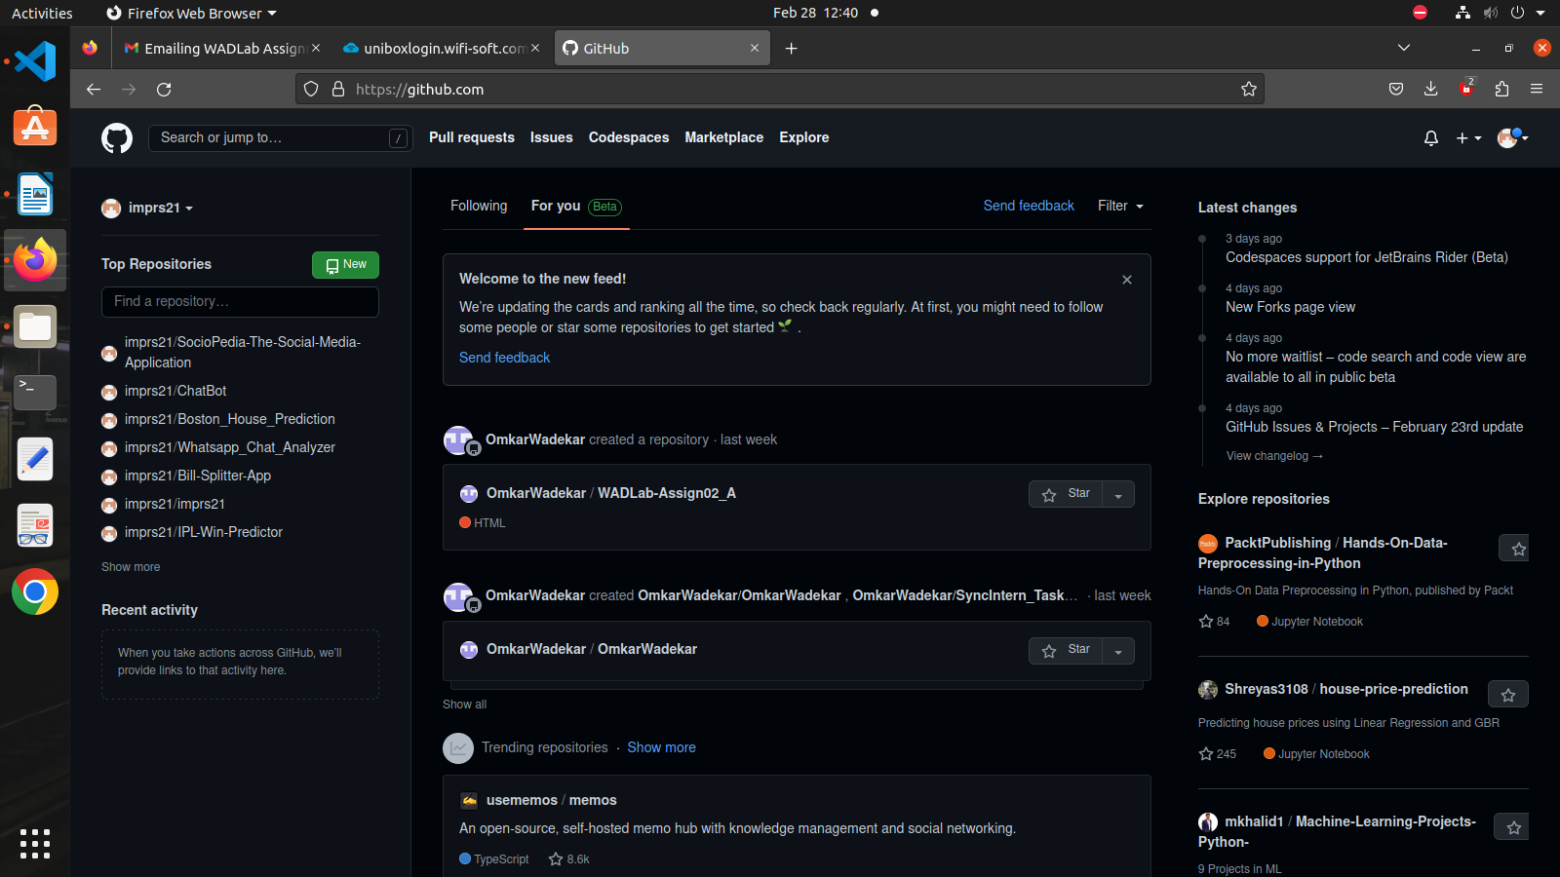
- Login with correct credentials and the following dashboard window will appear.

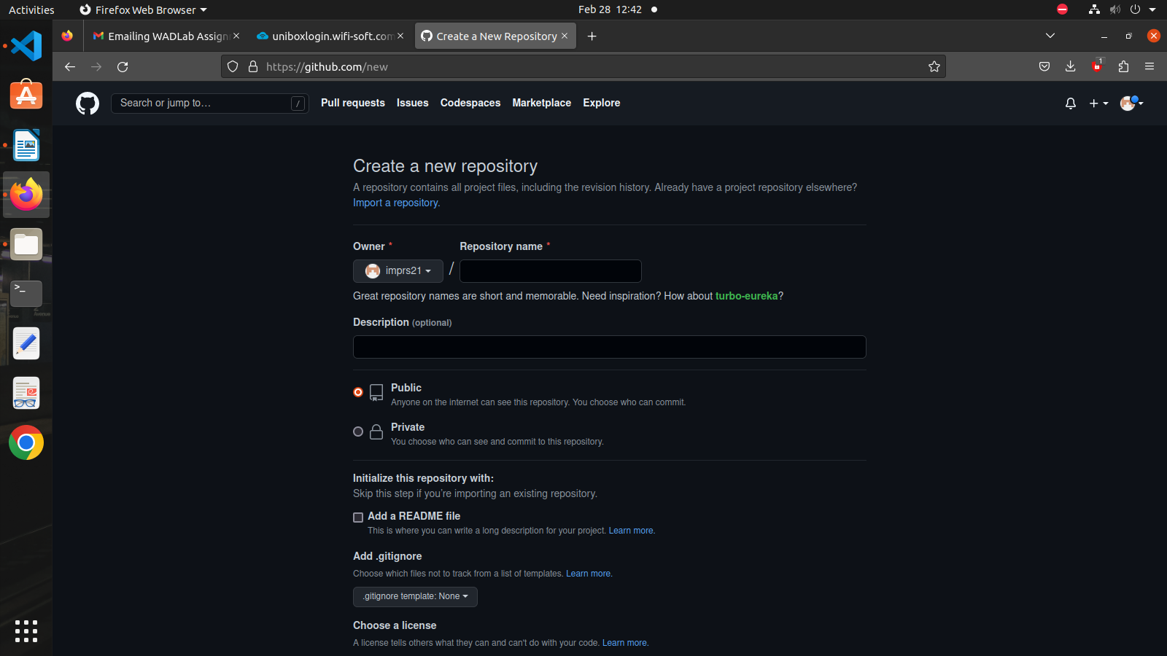
- Click on “New” to create a New Repository. The following window will appear.

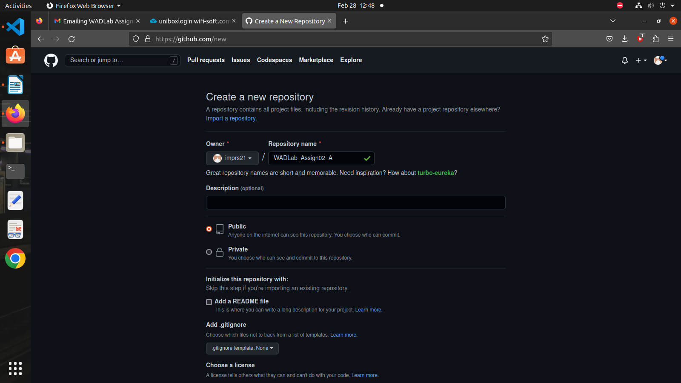
- Click on Create a Repository after giving an appropriate name to the Repository.

- Follow the instruction or commands given below (appears after performing previous step)
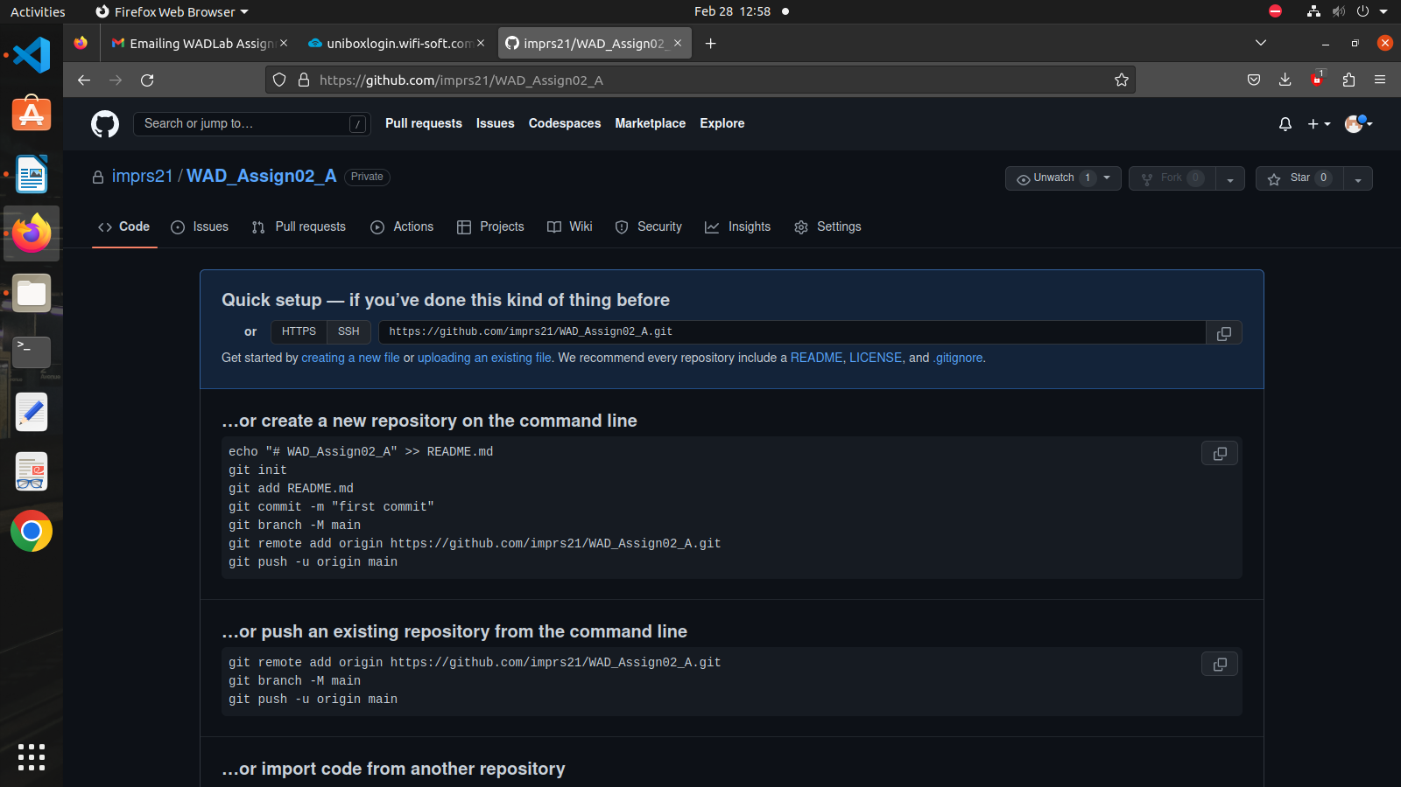
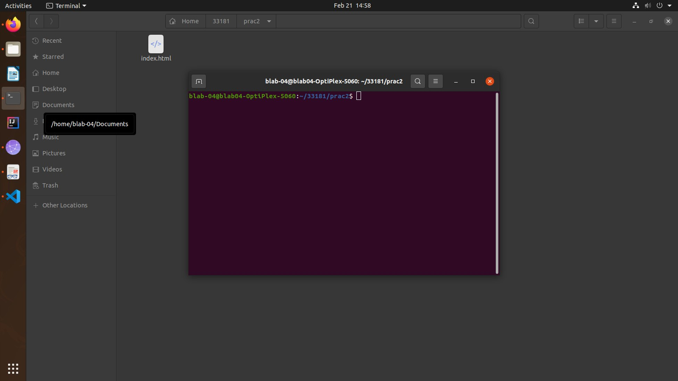
- To create a repository using command line open the Ubantu terminal inside the required folder

- Run the following command to initialize empty git repository: git init
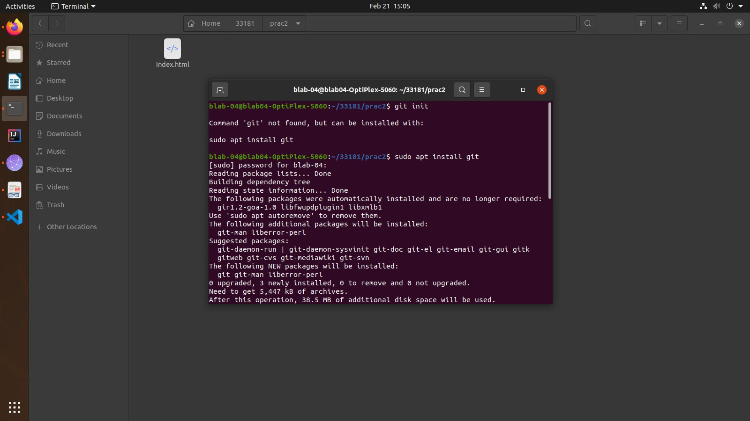
If git is not installed install it using : sudo apt install git

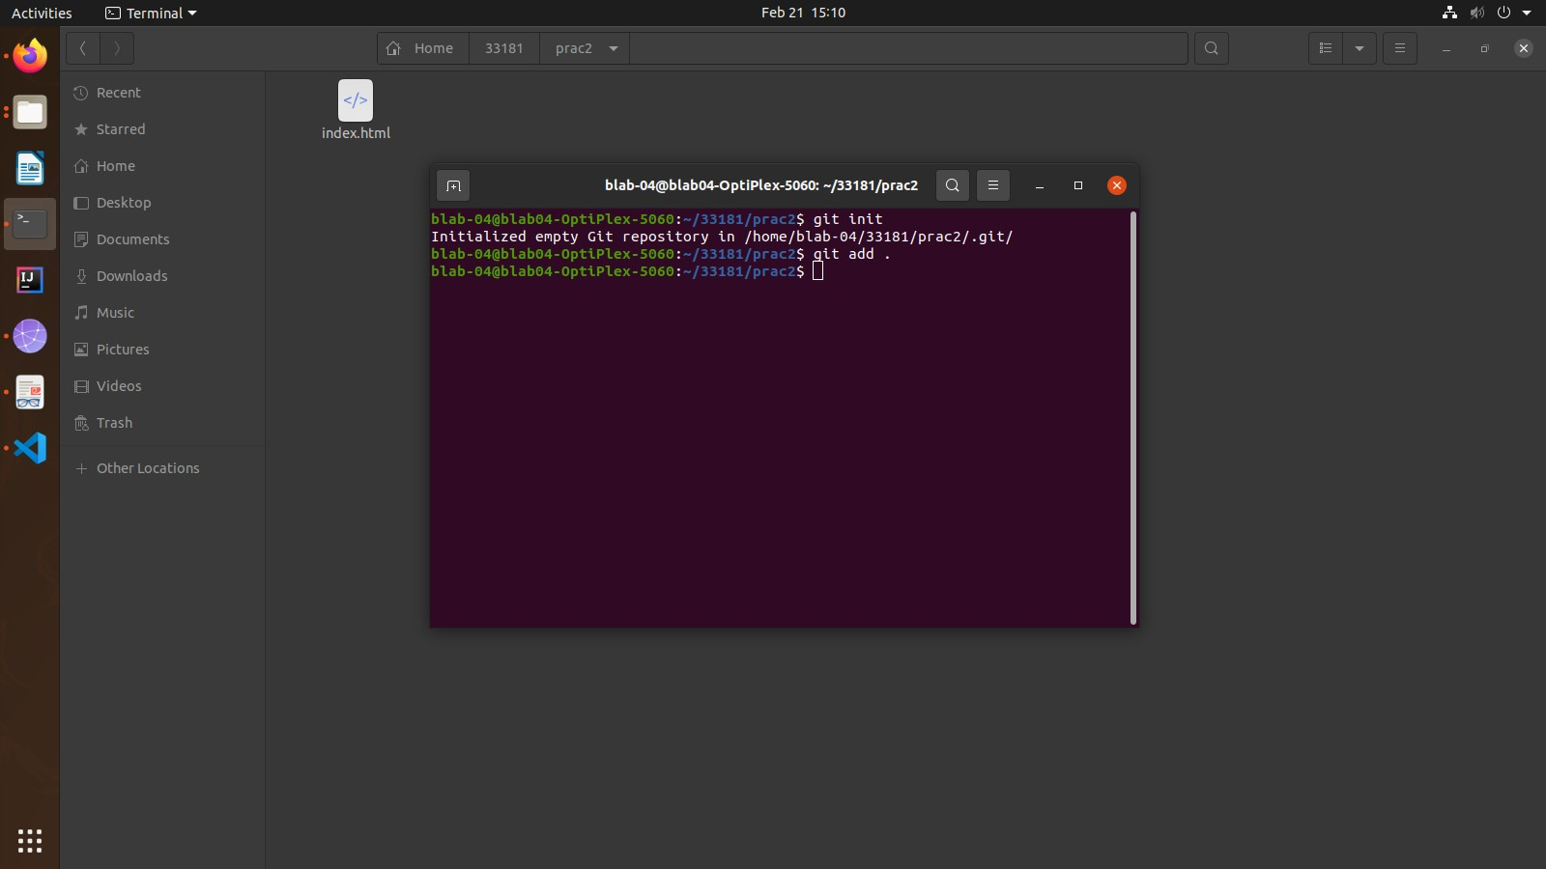
- Run the following command to add all the files to the local machine or staging area : git add .
- Run the following command so that user is identified by the system: git config --global user.email "you@example.com"
git config --global user.name "Your Name"

- Run the following command to commit the contents using a message given after -m: git commit -m "first commit"
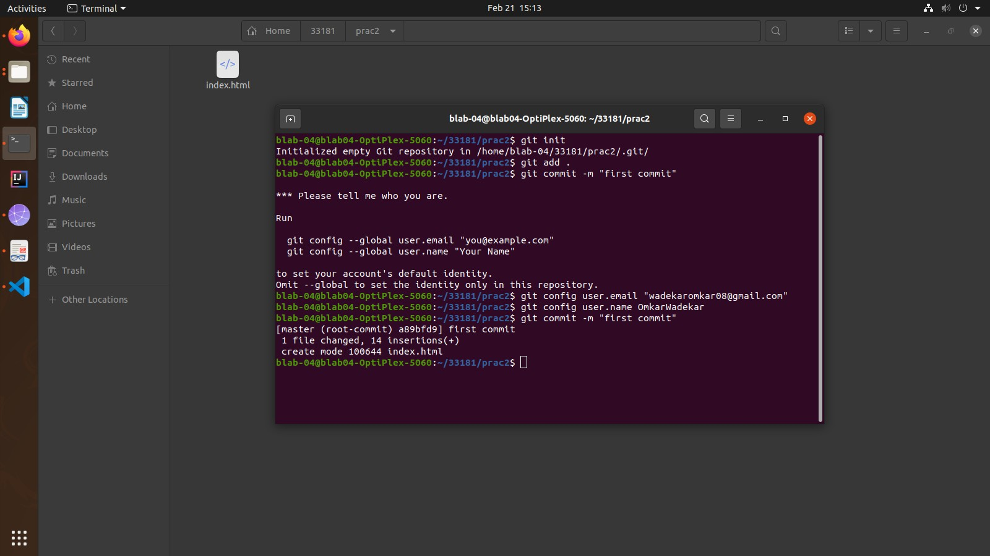
- Run the following commands one by one : git branch -M master
git remote add origin repository_link
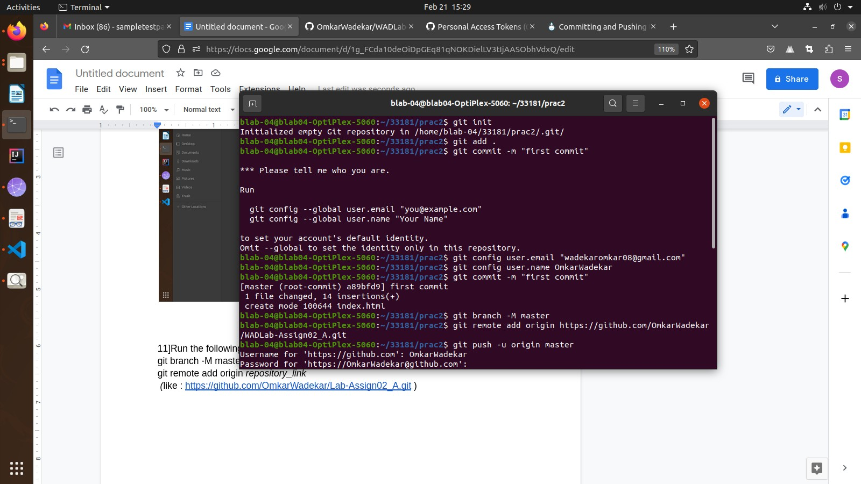
(like : https://github.com/imprs21/WAD_Assign02_A)
- Run the following commands along with account details (instead of password paste the Personal Access Token)
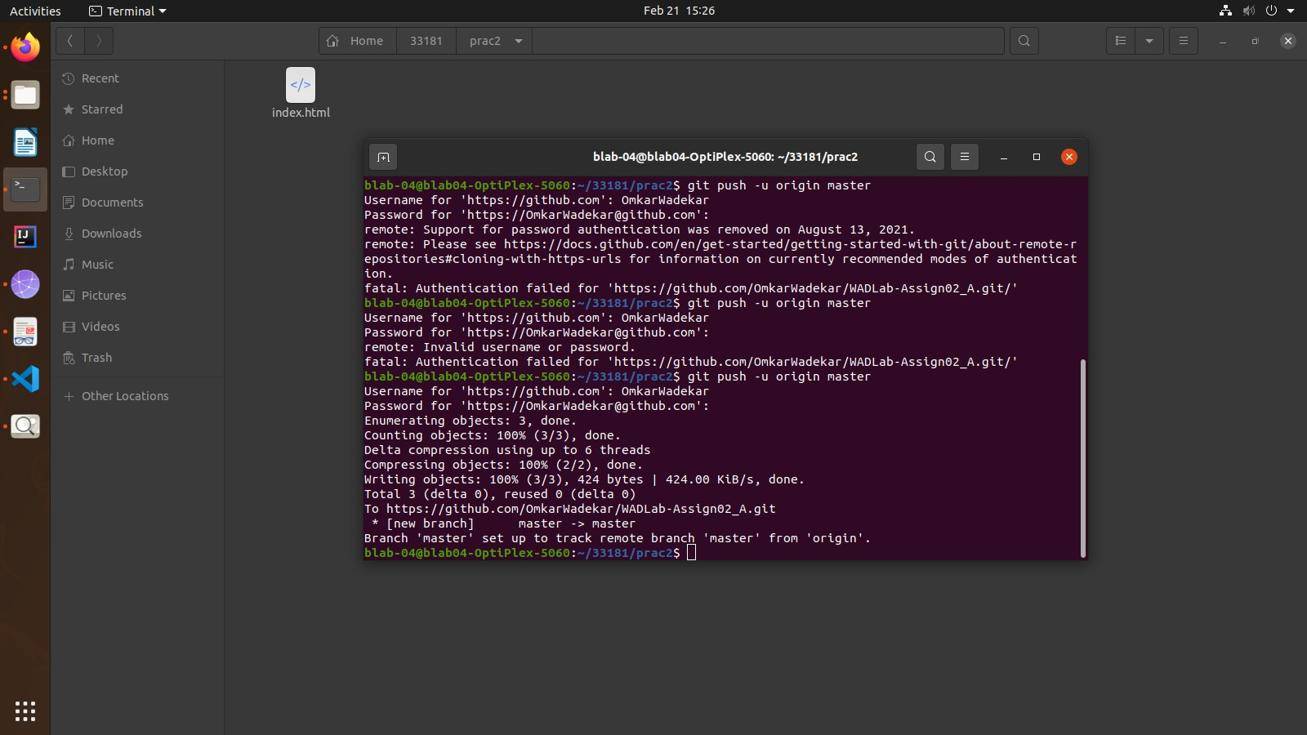
git push -u origin master

- To generate a personal access token visit:
https://docs.github.com/en/enterprise-server@3.4/authentication/keeping-your-account- and-data-secure/creating-a-personal-access-token
- After following all the above mentioned steps you can check that all the files in the local folder are uploaded to the newly created repository on GitHub
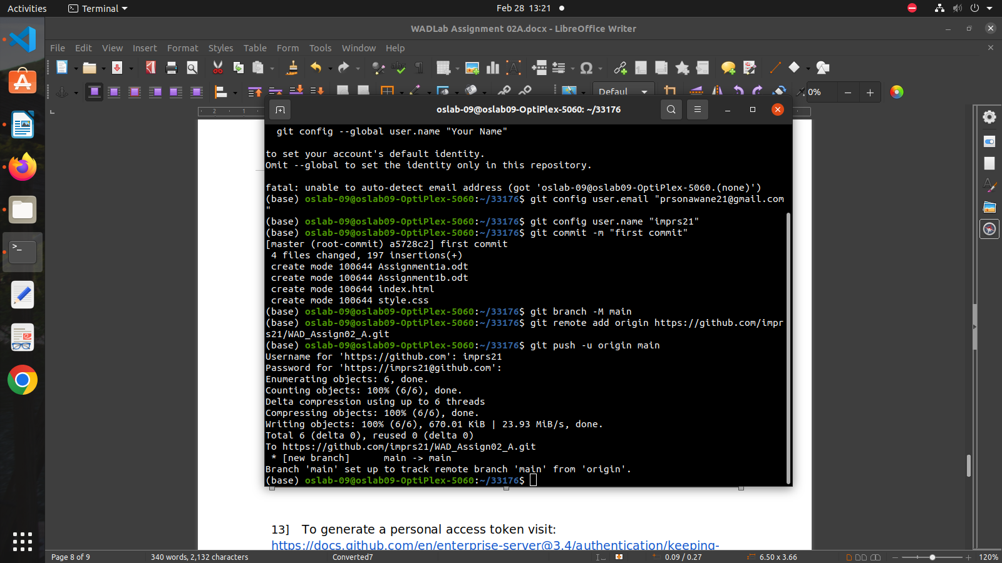

Conclusion:
Successfully learnt how to create a repository and push the entire code on GitHub and repository link for the same is given below :
https://github.com/imprs21/WAD_Assign02_A

